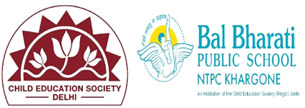
WEBSITE REPORT OF INVESTITURE CEREMONY
JULY 2024

NAME OF EVENT: EK BHARAT SHRESTHA BHARAT -ESSAY WRITING
THEME: ALL ABOUT MANIPUR & NAGALAND
DATE OF EVENT :29th July 2024
PARTICIPATING CLASSES: Classes IX & X
NO. OF STUDENTS PARTICIPATED: 25

The Ek Bharat Shrestha Bharat (EBSB) initiative aims to promote unity in diversity, enriching understanding between different cultures within India. As part of this initiative, an essay writing activity was conducted for students of Classes IX and X, focusing on the states of Manipur and Nagaland.
The Ek Bharat Shrestha Bharat essay writing activity was a successful endeavour, enriching students' knowledge and appreciation of Manipur and Nagaland. It served as an excellent platform for promoting national unity and cultural exchange, reinforcing the idea of "Unity in Diversity" that defines India. The students' participation and enthusiasm were commendable, reflecting the success of the initiative in achieving its goals.

Learning Outcomes
The students learnt:-
- about the cultural, historical, and social aspects of Manipur and Nagaland.
- based on their research, to write essays that were both informative and reflective. They expressed their newfound knowledge and personal experiences with enthusiasm/
- to develop a sense of pride in India's diversity and encouraged mutual respect among students.

