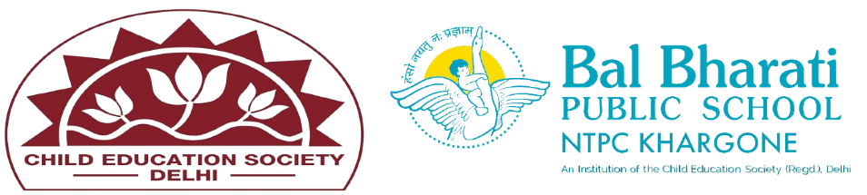

NAME OF EVENT: YOGA
THEME: ALL ABOUT MY SELF
DATE OF EVENT: 21st JUNE 2024
PARTICIPATING CLASSES: Classes BAL VATIKA- I, II, III
NO. OF STUDENTS PARTICIPATED: 44

On 21st June 2024, BBPS Khargone celebrated International Yoga Day for classes BV I to BV III. Students enjoyed activities like Mirror Yoga, Crawling with Objects, Blind Men's Buff Yoga, Balancing Yoga, and Animal Poses in Yoga. These activities enhanced their concentration, balance, and coordination, making the event a great success.
Learning outcomes in short:
1.Enhanced Physical Coordination and Balance.
2.Better Concentration and Focus.
3.Fostered Creativity and Problem-Solving.

