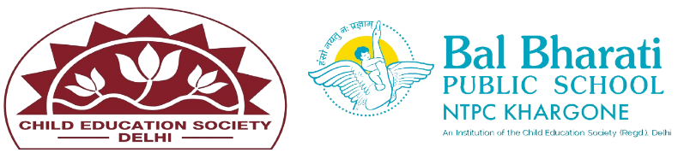
NAME OF EVENT: CREATE A SECRET IDENTITY
THEME:MY COUNTRY, MY PRIDE
DATE OF EVENT: 29th AUGUST 2024
PARTICIPATING CLASSES: Classes BAL VATIKA- I, II, III
NO. OF STUDENTS PARTICIPATED: 29
Our Pre-primary students participated in an exciting BAL SABHA activity called "Secret Identity." Through engaging role plays, the children explored the lives of India’s unsung heroes, embodying values like honesty, hard work, and love for the nation.
Learning Outcomes: -
1. Language Development.
2. Social Skills
3. Emotional Development.
4. Cognitive Skills.
5. Imagination and Creativity.
6.. Motor Skills.
8.. Self-confidence

