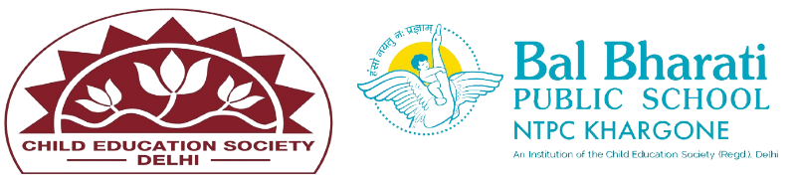
NAME OF EVENT: RAKHI MAKING ACTIVITY
THEME: MY COUNTRY, MY PRIDE
DATE OF EVENT :16th July 2024
PARTICIPATING CLASSES: BAL VATIKA- I, II, III
NO. OF STUDENTS PARTICIPATED: 40
Our Rakhi Making Activity was a beautiful blend of creativity and cultural values! Students came together to craft unique rakhis, symbolizing the cherished bond between brothers and sisters. This event not only enhanced their artistic skills but also deepened their understanding of the festival's significance.
Students enhanced their -
*Creativity and Artistic Expression
* Cultural Awareness and Appreciation
* Fine Motor Skills Development
* Patience and Focus
* Social Interaction and Collaboration

