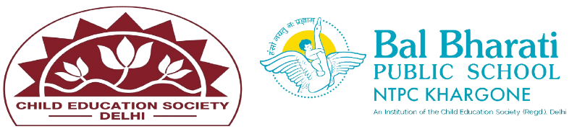
NAME OF EVENT: JANMASHTAMI CELEBRATION
THEME: MY COUNTRY, MY PRIDE
DATE OF EVENT: 23rd AUGUST 2024
PARTICIPATING CLASSES: BAL VATIKA- I, II, III
NO. OF STUDENTS PARTICIPATED: 38
On 23rd August 24, the pre-primary section of came alive with the vibrant celebration of Janmashtami, a festival that marks the birth of Lord Krishna. The young children participated with great enthusiasm, making the event both educational and enjoyable.
The highlight of the event was the Krishna Leela, where the little ones dressed up as Radha, Krishna, and other characters from Krishna’s life. They participated in a delightful dance performance, showcasing their talents and bringing the stories of Krishna to life. The innocence and charm of the tiny tots as they enacted the roles of Krishna and Radha.
Students enhanced their-
1. Cultural Awareness
2. Storytelling and Mythology
3. Moral Lessons
4. Creativity and Art
5. Teamwork and Cooperation
6. Cultural Performances
7. Respect for Traditions
8. Spiritual Development

