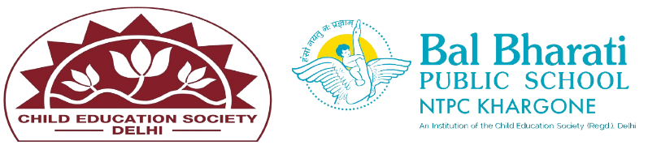
NAME OF EVENT: Friendship Day celebration
THEME: My country, My pride
DATE OF EVENT :8th July 2024
PARTICIPATING CLASSES: Classes BAL VATIKA- I, II, III
NO. OF STUDENTS PARTICIPATED:40
Students gather in classrooms or activity halls to create friendship bands. They use colorful threads, beads, and charms to design their unique bands. This activity not only allows them to express their creativity but also gives them a chance to make something special for their friends. Band Exchange: Once the bands are ready, students exchange them with their friends. This exchange is often accompanied by warm hugs, laughter, and sometimes even a few heartfelt words.
Students enhanced their -
- Understand the value of friendship
- Social skill development
- Creative expressions

