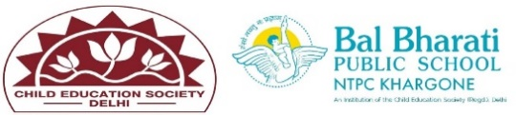
INTER HOUSE REPORT
EVENT:- Cartoon Chitran
CLASSES VI -to X
DAY & DATE:- 30th September 24
The cartoon chitran initiative at Bal Bharati School has proven to be an effective tool for promoting gender equality among students. Students learnt about SDG goal, gender equality through Cartoon Chitran.
RESULTS:
CLASS-IV -X
Class | NAME OF STUDENTS | HOUSE NAMES | POSITION
X | Nikhil Bhamoriya | Subhash | l
X | Mahi Patel | Shivaji | ll
VI | Prathvi Dev | Ashoka | lll

Students learnt :-
- To promote understanding of gender equality among students.
- To create a fun and engaging learning environment that sparks conversations on gender-related issues.
- To encourage students to express their thoughts and ideas on gender equality through art.

