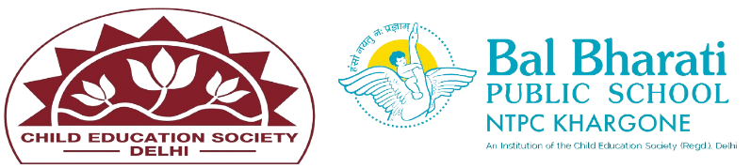
NAME OF EVENT: Origami Activity (AEROPLANE MAKING
THEME: Air
DATE OF EVENT : 16th October 24
PARTICIPATING CLASSES: Classes BAL VATIKA- I, II, III
NO. OF STUDENTS PARTICIPATED:39
On 16th October 24 an exciting Origami Aeroplane Making Activity was conducted for a Bal Vatika l,ll,lll kids .This engaging session combined creativity, hands-on crafting, and the basics of aerodynamics in a fun and educational environment. The activity aimed to not only teach the children how to fold a paper plane but also to help them understand the principles of flight through experimentation and play.
Students enhanced their -
- Creativity, imagination and aesthetic sense .
- Fine motor skills.
- Hand-eye coordination.
- Teamwork and Communication.
- Problem solving.
- Follow Instructions.

