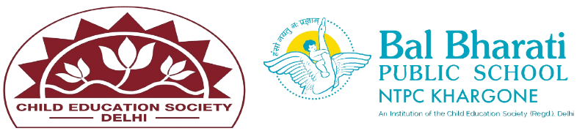
NAME OF EVENT: Special Assembly
SEFTY ON ROAD
THEME: Air
DATE OF EVENT : 21th October 24
PARTICIPATING CLASSES: Classes BAL VATIKA- I, II, III
NO. OF STUDENTS PARTICIPATED: 38
On 21th November 24 a special road safety activity was conducted for our Bal Vatika ll,lll students to raise awareness about the importance of road safety. The program aimed to familiarize young children with basic traffic rules, pedestrian safety, and the importance of responsible behavior on the roads.

Students enhanced their -
- Recognize basic traffic signals and road signs.
- Understand how to cross the road safely with the help of an adult.
- Learn the importance of wearing helmets while on a bicycle and using seatbelts in vehicles.

- Demonstrate good pedestrian behavior.

