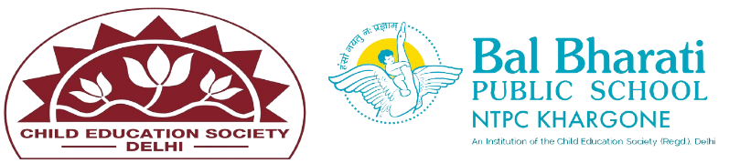
NAME OF EVENT: Navdurga Swaroop Abhinaya
THEME: Air
DATE OF EVENT :7th October, 24
PARTICIPATING CLASSES: Classes BAL VATIKA- I, II, III
NO. OF STUDENTS PARTICIPATED: 39
Our little stars at Bal Vatika brought the essence of Navdurga Swaroop to life with their captivating performances during the Navratri festival!
Dressed as Shailaputri, Brahmacharini, Chandraghanta, Kushmanda, Skandamata, Katyayani, Kaalratri, Mahagauri, Siddhidatri, and other divine forms, they mesmerized the audience with enchanting portrayals of mythological stories like the epic battle between Goddess Durga and Raktbeej. The children's performance beautifully highlighted the values of Dharma, courage, knowledge, devotion, compassion, and truth, demonstrating the cultural and spiritual significance of the occasion.
. Students enhanced their -
- Cultural Awareness and Respect.
-Moral and Ethical Lessons.
-Creative and Artistic Expression.
-Spiritual and Emotional Growth.
-

