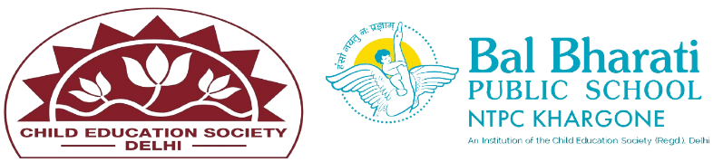
NAME OF EVENT: Bal Sabha Activity (POETRY SLAM)
THEME: Air
DATE OF EVENT : 24th October 24
PARTICIPATING CLASSES: Classes BAL VATIKA- I, II, III
NO. OF STUDENTS PARTICIPATED: 40
Today, our little wonders from Balvatika lit up the stage with their heartwarming performance in the Poetry Slam activity through Action and Emotions !
Dressed in vibrant costumes, they captivated the audience with their language abilities, acting skills, and remarkable stage confidence.
*Learning Outcomes*
•Language Development
• Confidence Building
•Creativity
•Collaboration
•Creativity and Imagination
•Listening and Comprehension

