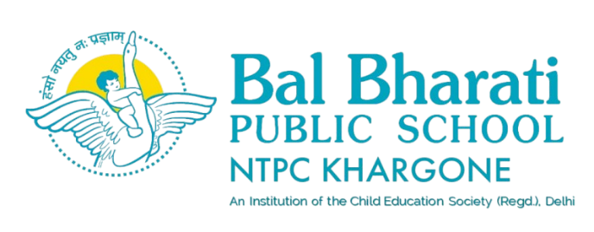

NAME OF EVENT: INTER-STATE EXCHANGE PROGRAM
DELHI & MADHYA PRADESH
THEME: REPUBLIC DAY SPECIAL
DATE OF EVENT: 21st JANUARY 2025
PARTICIPATING CLASS: VIII & IX
NO. OF STUDENTS PARTICIPATED: 25

An Exchange program was held with the students of Bal Bharati Public School, Madhya Pradesh and the students from the state of Delhi to foster cultural understanding and patriotism, culminating in a Republic Day-themed discussion and celebration.
Students explored the geographical diversity of Madhya Pradesh and Delhi. Discussions covered neighbouring states, prominent rivers like Narmada and Yamuna, mountain ranges like the Vindhyas, and famous monuments including the Sanchi Stupa and Qutub Minar. Insights were shared on great leaders like Chandragupta Maurya, Rani Lakshmibai, and Mahatma Gandhi, emphasizing their contributions to India’s independence and unity. Special attention was given to the Ashoka Chakra on the national flag, its meaning, and its importance in promoting harmony and progress.
A detailed discussion on the Preamble of the Indian Constitution helped students understand the ideals of justice, liberty, equality, and fraternity that guide the nation. Madhya Pradesh students highlighted their state’s cultural richness, tribal heritage, and natural beauty. Delhi students emphasized their city’s status as the political and historical hub of India, showcasing iconic events like the Republic Day parade.
Learning Outcomes
- Cultural Awareness and National Pride:
Participants gained a deeper understanding of India’s diversity and developed a sense of pride in the nation’s shared heritage.
- Enhanced Collaboration and Communication Skills:
The exchange of ideas and teamwork during creative sessions strengthened students’ interpersonal and collaborative skills.
- Civic Understanding:
Students learned the significance of national symbols, the Constitution, and Republic Day, fostering a greater sense of responsibility as future citizens of India.
_________________________________________________________________________________

