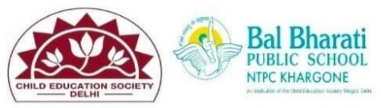
WEBSITE REPORT
NAME OF EVENT: INSPIRATION SERIES
THEME: Alumnus Interaction: Sarthak Suryavanshi Inspires Current Students
DATES OF EVENT: 25th JANUARY 2025
PARTICIPATING CLASS: VI to IX
NO. OF STUDENTS PARTICIPATED: 20

Our school was privileged to welcome alumnus Sarthak Suryavanshi for an enlightening session with the current batch of students. Drawing from his own experiences, Sarthak shared valuable insights on key aspects of academic success and personal growth.
He spoke about the importance of time management during board examinations, encouraging students to plan effectively and prioritize tasks for optimal results. Emphasizing the role of NCERT books in CBSE exams, he advised students to focus on understanding concepts thoroughly to build a strong foundation.
On the topic of choosing the right subjects in Class 11, Sarthak shared how aligning academic choices with career aspirations can lead to better outcomes. He also discussed the significance of maintaining consistency, highlighting the importance of regularity and persistence in achieving long-term goals.
- Learning Outcomes:
- Students understood the role of effective time management and the importance of using NCERT books for academic success.
- They gained clarity on aligning subject selection with future career plans and maintaining consistency in their efforts.

RICHA BHARGAVA JOLLIFFE

