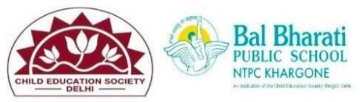
NAME OF EVENT: INTERNATIONAL EXCHANGE PROGRAM
COUNTRIES: INDIA & FINLAND
DATES OF EVENT: 27th JANUARY 2025
PARTICIPATING CLASS: IX
NO. OF STUDENTS PARTICIPATED: 16
An enriching International Exchange Program was held between India and Finland. This program was designed to promote cultural understanding and foster collaborative learning among young students from both countries.
The exchange provided students with a unique opportunity to engage in interactive sessions, virtual meetups, and joint activities that explored each nation’s history, geography, language, and art forms. With a focus on promoting global citizenship, the program allowed students to connect with peers in Finland and develop meaningful bonds, exchanging ideas and cultural perspectives. Students from both nations presented their respective cultural traditions through interactive communication session.
Learning Outcomes:
- Cultural Awareness and Sensitivity: The students developed a deep appreciation for Mongolian culture and heritage, while also reflecting on their own traditions. This helped foster an understanding of diversity and global inclusivity.
- Collaborative Problem-Solving: Through the joint projects, students enhanced their communication and teamwork skills. They learned to navigate cultural differences and worked together towards common goals, thereby strengthening their collaboration and critical thinking abilities.
- Global Citizenship: The exchange program instilled a sense of responsibility toward global issues. Students engaged in discussions around sustainability and environmental protection, preparing them to become proactive global citizens with a commitment to positive societal change.

RICHA BHARGAVA JOLLIFFE
27th JANUARY 2025

