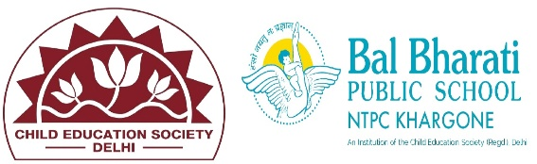
New Year Assembly Celebration by Class VII

Today, the students of Class VII organized a vibrant and inspiring New Year Assembly to welcome 2025 with positivity and enthusiasm! 

The program began with a serene prayer, followed by a thoughtful speech on embracing new beginnings. Highlights of the assembly included
 Dance & Music: Energetic performances that brought the spirit of the New Year alive.
Skits: A creative presentation titled "New Year, New Hopes", inspiring everyone to learn from the past and strive for a better future.
Resolutions: Students shared meaningful resolutions to make 2025 productive and impactful.

The Principal concluded the event with an encouraging message, reminding everyone to make each day count.

 This assembly was a perfect start to the year, filled with joy, inspiration, and togetherness. Wishing everyone a happy and prosperous 2025! 

