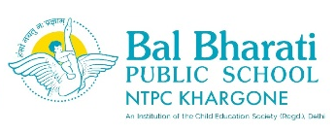

REPORT OF MOCK PARLIAMENT

DAY AND DATE: 17th April 2025, Thursday
On 17th April, 2025 Bal Bharati Public School NTPC Khargone organized a Mock Parliament session aimed at providing students with a platform to understand the functioning of the parliamentary system in a democratic setup. The event was held in the school and witnessed enthusiastic participation from students of classes VI to X .
Students were assigned various roles such as the Prime Minister , Speaker, Leader of the Opposition , Cabinet Ministers ,and Members of Parliament (MPs) from different political parties. The house was called to order by the speaker, and the proceeding began with the oath taking ceremony by new minister,Question Hour , where the opposition raised issues related to education, unemployment, environment, and national security. This was followed by a debate on a topic “free internet service”mock bill. Students actively engaged in discussions, raising strong arguments both in favor and against the bill.
The Speaker maintained decorum in the house and ensured that each MP got an opportunity to voice their opinions. After a thorough discussion, the bill was put to vote and was passed by a majority.

Learning Outcomes:
- Understand parliamentary system, including the roles of the government and opposition.
- Gain insight into how laws are proposed, debated ,amended, and passed.
- Develop communication and public speaking skill..
- Develop leadership skill.

