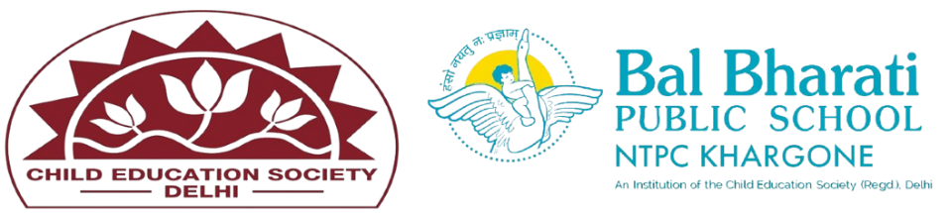

Industrial Visit Report

Venue: NIMAR BAKERY
Date: 26/04/2025

Our school organized an industrial visit to Nimar Bakery on 26th April, 2025, offering students a valuable opportunity to explore the baking industry and understand the essential role of microorganisms in food production. The main objectives of the visit were to:

Understand the baking process and the role of yeast fermentation.

Learn about food safety and hygiene practices in a professional bakery environment.

Observe the practical application of microorganisms in food production.

During the visit, students received a guided tour of the bakery. They observed the various stages of the baking process and were introduced to a wide range of breads and pastries. The bakery staff provided an in-depth explanation of yeast fermentation, demonstrating how yeast is crucial in the bread-making process by helping dough rise and enhancing the flavor and texture of the final products.

In addition to the baking process, students were educated about the importance of maintaining strict food safety and hygiene practices. The staff emphasized procedures for proper ingredient handling

