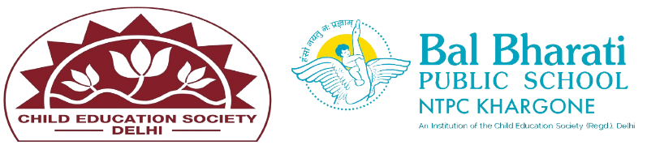
NAME OF EVENT: Water for All
THEME: My self
DATE OF EVENT :12TH April,2025
PARTICIPATING CLASSES: Classes BAL VATIKA- II, III
NO. OF STUDENTS PARTICIPATED: 27
As part of our ongoing efforts to nurture environmental awareness among young learners, a special assembly on the theme “Water for All” was conducted, aligning with the Sustainable Development Goal 6 – Clean Water and Sanitation. The assembly aimed to help Montessori children understand the importance of water in a joyful and age-appropriate way. Children learned about the value of clean water and simple ways to avoid wasting it. The highlight was a water pledge recited by the children, affirming their commitment to saving water. This meaningful and playful session helped instill a sense of responsibility in our little ones as future guardians of nature.. Students enhanced their -
* Learning Outcome
* Water is precious and should be used wisely.
* Ways to save water at home and in school.
* Everyone has a role to play in taking care of nature.

