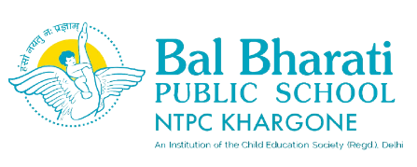
Name of Event: My Impression My Creation
Theme: My Self
Date of Event: 25th April, 2025
Participating classes: classes Bal Vatika- II, III
No. Of students participated: 20

The "My Impression, My Creation" activity was a fun and creative event where children used colors, palm prints, and fingerprints to create artwork. It encouraged self-expression, enhanced fine motor skills, and fostered imagination. The activity was a valuable learning experience, allowing children to develop important skills while having fun.
- Learning Outcomes
•Creativity Development: Encouraged creativity and self-expression.

•Fine Motor Skills: Improved fine motor skills and coordination.

•Imagination Encouraged: Stimulated imagination and innovative thinking.

